## WHAT IS THE PROJECT VIDEO (1)

[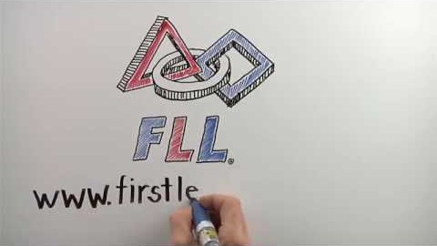](https://youtu.be/17PF_VimR2I)

## WHERE TO START VIDEO (2)

[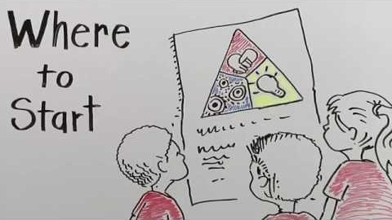](https://youtu.be/U0GRalUUt00)

## PRESENT YOUR PROJECT VIDEO (3)

[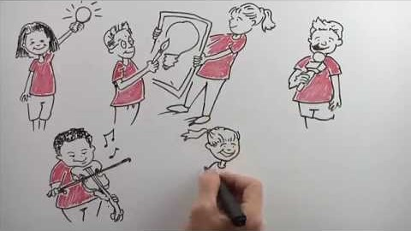](https://youtu.be/17PF_VimR2I)