[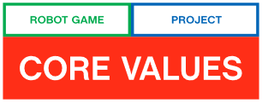](https://www.youtube.com/watch?v=VWlZZ5kGFIs&feature=youtu.be)

The Project and the Robot Game are what the students do. *FIRST* Core Values are how they do it.

The Core Values are the heart of *FIRST*. By embracing the Core Values, participants learn that friendly competition and mutual gain are not separate goals, and that helping one another is the foundation of teamwork. We will be reviewing the *FIRST* Core Values with our team and discuss them whenever they are needed, We will be expressing the *FIRST* philosophies of Gracious Professionalism and Cooperation through our Core Values:

* + Discovery: We explore new skills and ideas.
  + Innovation: We use creativity and persistence to solve problems.
  + Impact: We apply what we learn to improve our world.
  + Inclusion: We respect each other and embrace our differences.
  + Teamwork: We are stronger when we work together.
  + Fun: We enjoy and celebrate what we do!

GRACIOUS PROFESSIONALISM – “Learn and compete like crazy, but treat one another with respect and kindness”

# Judging Core Values – Overview

* Judges present a team activity
* The team will then get to present their Core Values poster
* Judges will ask follow-up questions about events presented on poster, and additional questions about applying core values outside of FIRST LEGO League